**Assignment** [**Feb8-DFDPetriNetStatemachine**](https://stthomas.instructure.com/courses/40991/assignments/505494)

**Course: 610-Software Engineering**

**Submitted by: Shivali Dalmia**

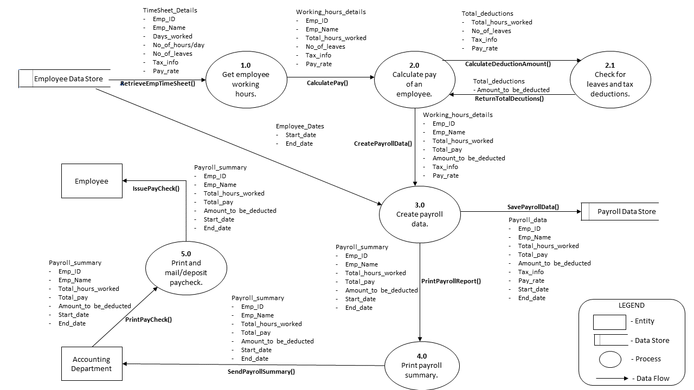**DFD for a simple payroll system**

**State Machine for a Toaster**

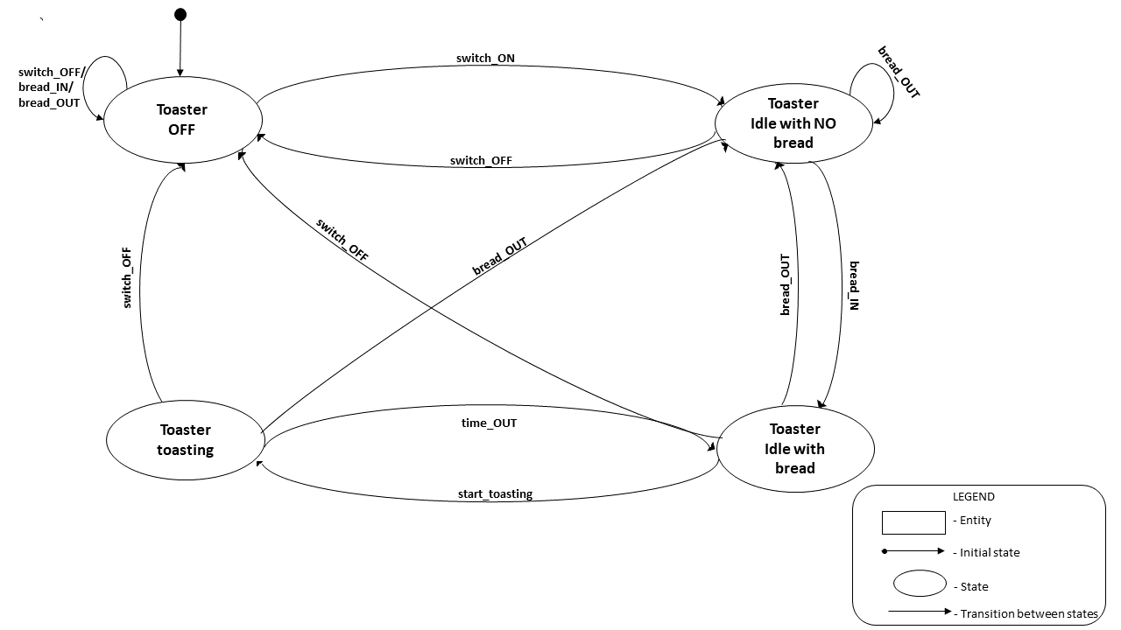

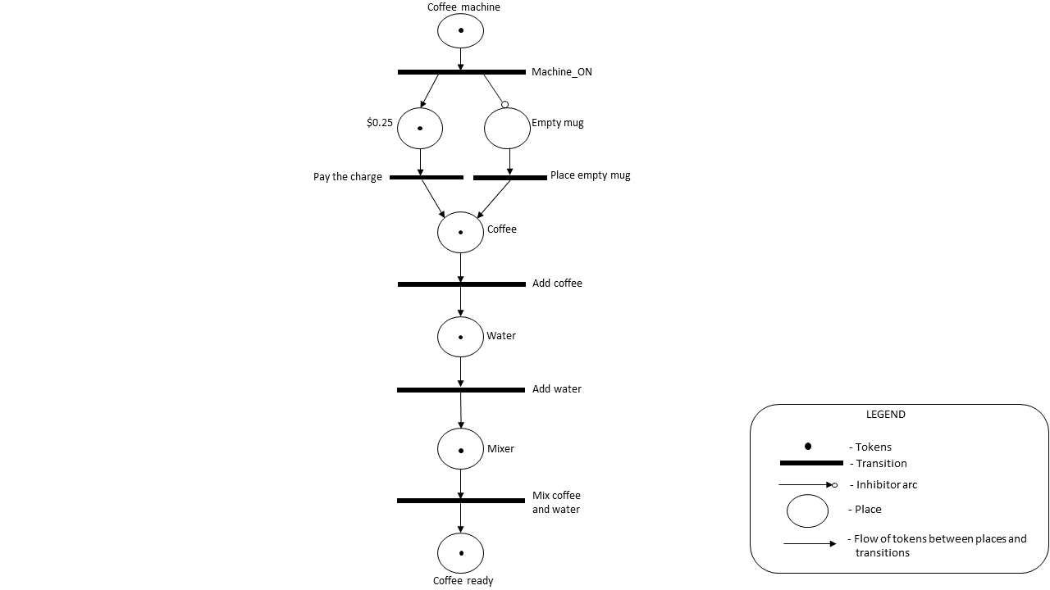**Petrinet for an instant coffee machine**